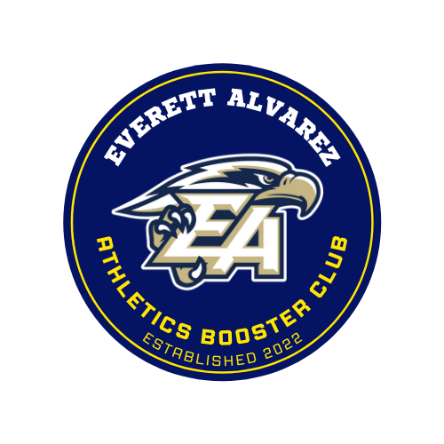
Everett Alvarez Athletics Booster Club
Continuous Meeting Minutes

General Boosters Meeting
Wednesday October 18, 2023
Room 105 - Everett Alvarez High School

Meeting called to order at 6:10pm

Board Members Present: Vice President David Vazquez, Treasurer Felix Cervantes, and Secretary Sabrina Kau
Absent: President Brian Vazquez, Director of Membership Services Lorena Vida, Winter Trustee Chris Jackson and Spring Trustee Sonia Amador

General Members: Erik Morales and Gerrie Kau

Vice President Report:

Coach McKay is asking to be reimbursed for meals after a group of 5 Football players attended a Football Leadership Conference in Santa Clara with the San Francisco 49ers. Receipt in the amount of $113.43 was submitted. The EAABC board was notified via text message of this request the night prior to the event. The board unanimously agreed to support them.

Lorena submitted receipts in the amount of $218 for last minute items need and purchased the day of the BBQ fundraiser. No Nays to reimburse, check to be issued.

Treasurers Report: Our account was charged $1.25 service fee for Zelle use.

Next events…

Friday October 20 is our annual PINK GAME. This is “biggest” crowd/game we’ve had this season
Parking - President would like for the EAABC to handle parking. In order for parking to run smoothly we will need 7 volunteers. We need to email all members to ask if anyone is available to help. Possible help - Marvin Gerrie’s brother and Felix to reach out to 4 people.

We will still be running our 50/50 raffle and it is our last day for the 49ers Ticket Raffle. We will need help with coverage of the table and work the crowd with sells. Minimum of 3 people to cover table/crowd sells 1 at table and 2 working crowd sells.

Donate a portion of 50/50 raffle earning/winnings to the Interact Club. Gerrie Kau motions , Erik, motion pass.

Fall Seasonal Fundraiser final report tabled until next meeting.

New business

Implement a new procedure in regards to how we receive requests for funding. The coaches along with the athlete(s) present their request and then we approve their requests. Item tabled to next meeting for further discussion.

Fall Sports Banquet was briefly discussed due to not having an exact banquet date at the moment. We decided to have a banquet planning meeting on Wednesday November 8th at 6pm in AD Vazzy’s office. The board can utilize the board group chat to bounce ideas and have a starting point for the planning meeting.

Meeting was adjourned at 7:03pm

General Membership Meeting
September 20, 2023
6pm EAHS Room 105

Meeting called to order at 6:12pm

Board Members Present: President Brian Vazquez, Vice President Dave Vazquez, Secretary Sabrina Kau, Membership Director Lorena Vida, and Director of Social Media and Publicity Andrea Lucas
Absent: Treasurer Felix Cervantes, Spring Sports Trustee Sonia Amador, and Winter Sports Trustee Chris Jackson

General Members Present: Erik Morales

Vice President Report: 3 funding requests to approve

Girls Flag Football - $95.23 Fundamental equipment to get the program started. District provided 30 flags, 8 balls, 30 uniforms and 30 mouth Guards. EAABC to purchase following items - wristband play books, training equipment cones with shoulder strap and rung agility ladder. This request was sent to board members via group chat and approved via text message to expedite purchasing items as girls flag football season has already began.

Cross Country- $150 for cross country invitational. funds to be pulled from Cross Country sub-account. Brian motions to approve, Dave seconds motion. No Nays, request approved
$370 request for cross country invitational was sent via text message and approved via text message.

Water polo - $1,455 for suits, warm ups to promote team uniformity. Company that was used is Ryte Sport. Funds to be used from sub-account. Dave motions to approve, Brian seconds. No Nays, request approved. EAABC will use the debit card to expedite the purchase of items.

Secretary Report - Website is up and running. Board members' photos are still needed. A scholarship link was added with information/requirements and link to the application. Will work on adding all membership meetings dates and times for the rest of the school year.

Treasurer Report (via president) - Finance workbook will be more detailed in descriptions so there are no questions as to what each transaction is. General account is looking very healthy.

Membership Director Report - We have 19 members sign up besides board members. Continuing to reach out to Athletes parents to be a part of boosters.

Fundraisers:
50/50 - We have had small game crowds so sales are small. We did have 2 weeks donated right back to the EAABC.

Football Game Parking - Parking made about $1200 in parking last week. This additional fundraiser has been a nice extra fundraiser to help earn funds. We are looking to see when/how the best game is for the EAABC to handle the parking lot. To date Cross Country and Volleyball have handled parking.

49ers Ticket Raffle - 200 raffle tickets have been made. More tickets will be made after the BBQ to see if we can generate sales at the BBQ. Brian spoke with the athletic director at Salinas High and if we have a flyer is willing to let his school know that we will be selling tickets the night of the Salinas vs. Alvarez game.

Fall BBQ Fundraiser - Tickets have been distributed to the athletic teams. Turn in date for money or returned tickets is Friday 09/29/2023.
Will have a BBQ Organizational meeting on 10/04/23 5:30pm.

Athletic Request - Boys Soccer account with ASB is negative. Athletics is asking we help boys soccer and bring their ASB account positive. Exact amount needed to bring account positive will be requested from ASB and the EAABC will be notified.

Next general meeting 10/18/2023

Adjourned 7:02pm

Executive Board Meeting
September 6, 2023
EAHS Conference Room

Board Members Present: Treasurer Felix Cervantes, Director of Membership Lorena Vidauri, Vice President Dave Vazquez, President Brian Vazquez, Director of Social Media and Publicity Andrea Lucas, and Secretary Sabrina Kau
Late - Winter Sports Trustee Chris Jackson
Absent: Spring Sports Trustee Sonia Amador

Meeting called to order at 6:15pm.

Vice President Report:
Cross County submits a request for $175 for the team to participate in the Jackie Henderson Invitational to see where our team ranks amongst other PCAL schools. Brian motion to approve request Dave seconds motion. No nays motion passes.

Secretary Report: Website has been updated to add the Meeting Minutes to be accessible to the public. Sabrina will continue to work on the website and add more content and make it more informational for our members.

Treasurer's Report:
8/24 vs. Alisal Parking $1729
09/01 vs. Oak Grove Parking 945
08/24 and 09/01 50/50 Raffle $789
Parking earnings have been moved to sub accounts

Fundraiser:

Fall Sports Chicken BBQ Fundraiser Saturday October 07, 2023 Price: $15 per plate
Brian sent an email out to all Fall Sports Head Coaches to get a count as to which sports want to participate. Football, Cross Country, Volleyball, and Water Polo will participate. Cheer, Tennis and Golf will not.
Schedule:
09/11-09/29 -Team Ticket Sales
09/30-10/06 - EAABC Sales/Finalize Details/Prep
Menu:
¼ Chicken Legs, Salad, Beans, Dinner Roll, Drink, Desert
Per Ticket Profit
25% per ticket to team
33% per ticket to the team if the team would like to help by donating items, work the day of the bbq, etc.
Day of BBQ Timeline
12pm-4pm Distribution
7am Setup
8am Start BBQ Pit
4pm-6pm Clean up/Offsite

Donation letter to be drafted to take to local businesses (Safeway, El Super, Del Monte Meats) to see if they are able to help us with anything. Board agrees it is okay for Brian and Felix to use the club's credit card to get the items we can not get donated and purchase tickets.

Brian to put in facilities requests for every 3rd Wednesday of the month for general meetings. Board can meet prior to or after the meeting for discussion.

Meeting was adjourned at 7:22pm.

General Meeting
August 13, 2023
Room 105 EAHS

Board Members Present: President Brian Vazquez, Vice President David Vazquez, Treasurer Feliz Cervantes, Secretary Sabrina Kau, Director of Social Media and Publicity Andrea Lucas, and Winter Sports Trustee Chris Jackson. Absent Board Members:
Director of Membership Services Lorena Vidauri and Spring Sports Trustee Sonia Amador

General Members/Guests: Erik Morales and Nadine Pederson

Meeting Called to Order at 6:15pm

President Brian Vazquez calls the meeting to order and welcomes everyone for attending.
Nadine asks the question what are we about and our purpose. Brian explains our purpose and gives more information about our club.

Vice Presidents Report: There is one funding request from Boys Basketball in the amount of $2,100 for uniforms. The $2,100 will help subsidize the cost with ASB. Motion is made by Brian to approve the funds, Felix seconds the motion, no nays. Motion is passed. Check to be written to Everett Alvarez High School.

Secretary Report: Minutes are taken every meeting both board and general meetings. We try to have monthly general meetings but with very low membership and turn out to meetings, it becomes a board meeting. We are hoping this changes this year. We have a running meeting minute document that is regularly updated and will be published on the website and available for everyone to review. If there are any questions they can contact Sabrina for further explanation. Our goal is to always be transparent with our members, athletes and community.

Treasurer Report: Accounts are in the green. We are currently sitting at a total of $43,000 in the EAABC account. Felix can give a breakdown of each individual sport and EAABC balance upon request.

Membership Report: Lorena not Present, but Brian did state that she has reached personally by email to new members to welcome them and provide them with information on when their membership cards will be ready. New this year is a Go Fan member code to receive discounted ticket prices. Each member will have a special code to be used the whole school year.

Current Fundraisers:
-50/50 Raffle - numbers have been very low compared to last year but hoping to pick up as the season progresses.
- Football Game Parking - Cross Country worked the first game and Volleyball will work this Friday (09/01).

-49ers Football Game Raffle - Game to be raffled off is December 12, 2023 vs. Seattle Seahawks. Flayer was emailed to the board for review. Agreed to sell the raffle tickets 10/16-10/20 with the last selling opportunity being at the football game 10/20 vs. Salinas High.
Motion made by Chris to pay back Brian the face value of the tickets and parking pass. Felix seconds the motion, no nays. EAABC to pay Brian.

Perks Update: A donor has been found for the shirts. We hope they arrive soon.

Future Fundraisers: Fall Fundraiser - Chicken BBQ Saturday October 7, 2023 target date
Email to be sent out to all fall coaches with terms of our fall fundraiser and if they are interested in participating. We are asking should a team want to participate, each athlete on the roster is to sell 5 tickets. Should they need more, more will be provided upon request. September 11th-29th ticket sells. Turn in date for presale is September 29th. Should someone want to purchase tickets after the 29th, they can contact an EAABC board member. Each team will receive a part of the tickets they sell. Final details to be discussed at the Board Meeting on 09/06/2023.

Next General Meeting date is TBD.

Meeting was adjourned at 8:00pm.

Board meeting
August 16, 2023
EAHS Conference Room

Present: Treasurer Felix Cervantes, President Brian Vazquez, Vice President Dave Vazquez, Secretary Sabrina Kau, Social Media Andrea Lucas, Spring Trustee Sonia Amador, and Director of Membership Lorena Vidauri
Absent: Winter Trustee Chris Jackson

Meeting was called to order at 6:30pm

General Business:
Requests sent for approval via text message
- Cross Country - Shoes for runners. Did not exceed $1,000
- Boys Basketball - Spirit shirts invoice $550.30 - denied because we were provided an invoice, not a quote or receipt for reimbursement.
- Lumpia Sale at football games $125 - approved

Membership Dues for board members are due!!!!!

Board member duties were briefly explained/reviewed
Lorena and Brian to meet at a later time to go over duties and issuing of membership cards
Social Media doing a great job, a parent reached out regarding the next meeting as they are interested in being a part of the club.
Secretary, Vice President and Treasurer are status quo.
Trustee position duties explained to Sonia as she is the spring trustee.
Fireworks:
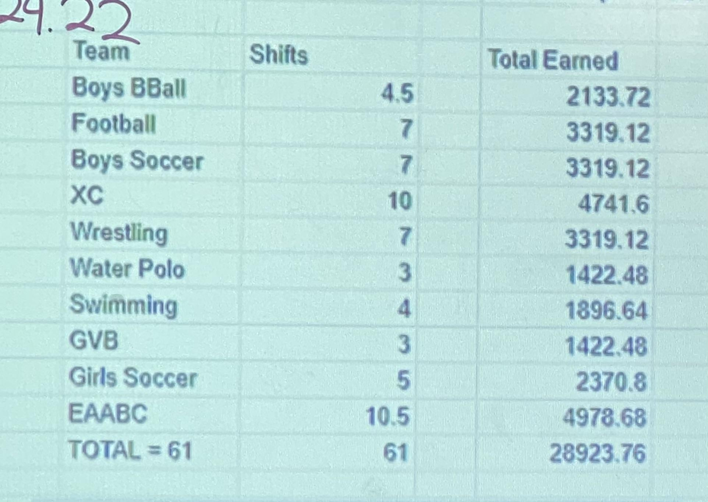
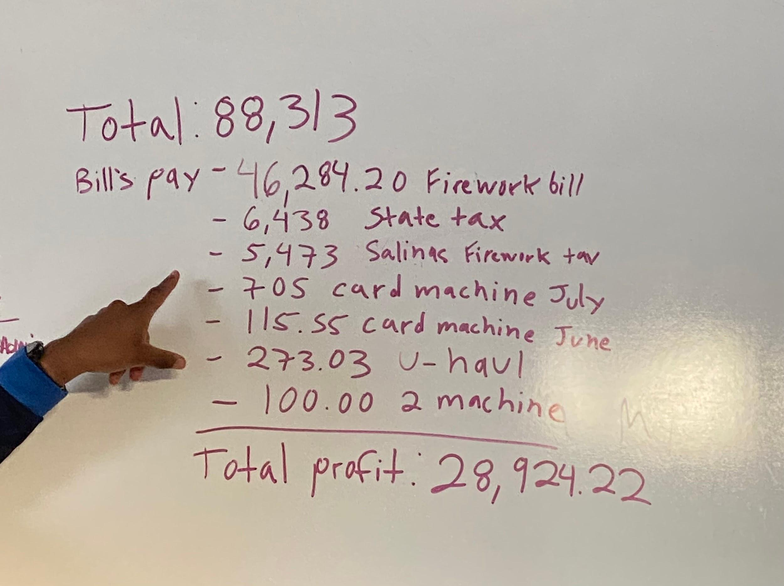
Please see below photos of total gross earned, expenses, and division of revenue.

Future fundraising possibilities:
Rodeo - Run stand, monster truck kid volunteers, the concert, and rodeo have to be adults. Sonia already does this fundraiser with another outside organization and there is a possibility that the EAABC can join in the summer of 2025 as the booths are rotated every 2 years amongst organizations.
NFL Football Tickets Raffle - Did well last year. Will do again. We just need to pick the 49ers game to raffle and the home football game to raffle it off at.
Season specific all athletic teams fundraiser. This allows athletic teams to earn more money during they’re season of sport. IE: All Fall Sports have a Tri-tip bbq, Winter Raffle, Spring chicken bbq. Items tabled to the next meeting so we can come back with ideas.

Football scrimmage this Friday
Impromptu 50/50? Yes! Accept Zelle drawing will be 8:30 must be present 18 and over
ASB offered Football Parking to EAABC. In order for it to work successfully and not feel stressed out we need 6-8 people to work the parking lot. Brian to ask athletic teams to help and man the gates. Revenue splits as follows:
50% - ASB
50% - EAABC
25% - EAABC general account
25% - Athletic team that worked the lot.

Perks update - shirt company to supply 200 shirts to give to members, and new this year free parking!!!

Next board meeting 09/06/23
Next General meeting 8/31/23

Meeting Adjourned: 8pm

EAABC GENERAL MEETING

Wednesday May 17, 2023
Everett Alvarez High School Room 105

Meeting Called to order at 6:10pm

Board Members present:President Brian Vazquez, Vice President Dave Vazquez, Secretary Sabrina Kau, Parent Advocate Lorena Vida
Absent: Fall Trustee Anthony McKay and and Spring Trustee Chris Jackson

General members present - Geraldine Kau

Agenda to be posted on website

Reimbursement for the winter sports banquet in the amount of $1,302.50 for Girls Basketball was issued to Coach Loretta Brown.

Scholarship winners Rosyln Olivo and Ivy Arellano will announce and present winners at spring banquet

Scholarship language currently states scholarships to be awarded to one male and one female, will ratify into bylaws if only one gender applies both to awarded to same gender

President Brian Vazquez speaks on how we finished our first year, that it was tough/challenging at times, but successful and likes the direction club is going.

Elections - Officers:
President, Vice President, Secretary, Treasurer, Director of Membership, Fall Trustee, Winter Trustee, and Spring Trustee.
President: Gerrie nominates Brian Vazquez as President for one more term. Felix seconds nomination, Brian accepts.
Vice President: Lorena nominates David Vazquez as Vice President for one more term. Gerrie seconds nomination, David accepts.
Secretary: Gerrie nominates Sabrina Kau as Secretary for one more term. Lorena, seconds the nomination, Sabrina accepts.
Treasurer: Dave nominates Felix Cervantes as Treasurer for one more term. Gerrie seconds nomination, Flex accepts.
Director of Membership: Dave nominates Lorena Vida to be new Director of Membership. Duties are explained to Lorena. Gerrie seconds nomination and Lorena accepts.
Fall Trustee: Brian motions to not re-elect Anthony McKay as fall trustee. Sabrina seconds the motion. Matter moves to vote: No Nays. Motion passes. Fall trustee will remain vacant until we can find someone to fill the position. Tabled to the next meeting.
Winter Trustee: Chris Jackson volunteers to be winter trustee. Sabrina motions to accept Chris volunteering to fill the position. Dave seconds the motion. Matter moves to vote. No nays, Motion passes. Chris is contacted via phone and accepts position.
Spring Trustee: Chris Jackson resigned from position to become winter trustee. Dave motions for Sonia Amador to fill the spring trustee. She is currently holding the Boys Volleyball program head which is a spring sport. Felix seconds the motion. Sonia is contacted by phone, duties as spring trustee are explained to her. Sonia accepts position as spring trustee.

New business:
Fireworks Booth June 28, 2023 - July 4, 2023
Seller Permit has been approved by the city
Fire Permit has been approved by the city.
U-Haul van has been reserved. Estimated rental cost for 6/27-7/6 @ noon is $385.
Merchandise ordered to sell is same quantities as last year. This year city tax is charged at 9.25% and a city surcharge fee is charged at 7% per item.
Credit Card machines have been ordered. Company is charging $50 per unit. We have ordered 2 units for a total of $100. We have decided to accept all major credit cards. The EAABC will inherit all service fees.
Brian gave a break down of shifts, how they are chosen by sports, and an example of fireworks earnings/costs (see below)
Shifts: Athletic director sends an email out to all head coaches asking to respond if they are interested in participating in working in the fireworks booth. Once all coaches have responded, a date is chosen to hold the wheel of luck drawing. There are a total of 61 - 2hr shifts. The EAABC will choose 5 shifts leaving 56 shifts for Athletics. On the day of the wheel of luck drawing, athletic teams are entered into the wheel, the team it lands on picks 2 shifts until all teams have chosen and then they are reloaded into the wheel and continue the pattern until all shifts have been filled.
Earnings/Costs Example:
Gross: $82,000
-$42,000 (merchandise)
$40,000
-$6,000 (EAABC 15%)
$34,000
-$300 (Van Rental)
$33,700
-$2,500 (Credit Card Fees)
$31,200
-$5,700 (7% City Surcharge. 7% of Gross $82,000)
$25,500
-$7,500 (9.25% City Tax. 9.25% of Gross $82,000)
$18,000
$18,000 then gets divided up amongst the 61 shifts = $295 per shift.

Executive Board workshop during the summer to go over bylaws and finalize fireworks scheduled for June 23, 2023.

No other business for the good of the order.

Gerrie motions to adjourned the meeting. Lorena seconds.

Meeting adjourned at 7:56pm

EAABC Executive Board Meeting

Thursday April 6, 2023

Present: President Brian Vazquez, Vice President Dave Vazquez, Spring Trustee Chris Jackson, Secretary Sabrina Kau, Parent Advocate Lorena Vida

Absent: Director of Membership Diana Mendoza and Fall Trustee Anthony McKay

Meeting called to order: 6:15pm

This board meeting will be the last board meeting before we hold the general meeting. General meeting needs to review what has been done this booster year, any revisions to bylaws and selection of a new board. Current Board Positions are as follows:

President
Vice President
Treasurer
Secretary
Director of Membership
- coordinator of social media and publicity
3 Season Trustees (spring, winter, and fall)

President suggest the following Revisions/Additions to be added to Bylaws:
Utilize booster money to purchase post season merchandise when athletic teams make playoffs (CCS patches, shirts) as well as help with funds for hotels, transportation, etc.
General fundraiser for each Sport Season; Fall, Winter, and Spring. Example of this years fundraisers: Fall-50/50 Raffle, Winter-Shots for Cash, Spring-TBD
These items will be brought up at the general membership meeting for discussion, voting, and adaptation.

President Report: Spring fundraiser Tri-tip BBQ- discuss with AG to possibly get a booth during the AG Street Fair which is the 6th of May. Too many activities happening on May 6th for us to be able to request the day solely for the BBQ fundraiser. Activities at EAHS on 5/6: GBA Slam Basketball Tournament, SATs, EAHS Drama Play, and EAHS AG Academy Street Fair. Brian to meet with Mr. Medrano regarding the AG Academy Street Fair and possibly getting a booth at the fair to have our BBQ. Thought thrown out of possibly sponsoring the AG Academy’s Street Fair, but that doesn’t align with our bylaws and mission as an Athletic Booster Club.
We are updating our Master club binder to add the board meeting minutes. Felix will start a new financial binder. Re-up our mascot media subscription. At the general meeting we will review all our bylaws. Club to re up our legal zoom subscription for at least one more year. Fireworks application has been approved for a booth. Brian received Doc U Sign documents to sign and submit for our fireworks application to the city. Documents signed and submitted. Re-up our mascot media subscription. We still have strip as an option to send invoices and collect money. After the general meeting and new officers have been elected, if any, we can establish how we want to move forward for the new year. General Membership meeting: Wednesday May 10th 6:30pm.

Treasurer Report: Taxes will be completed Saturday. Finally done with the credit card terminal. Daniel with Union Bank is working to get us refunded all months we we were charged a terminal fee that we did not use the readers.

Vice President Report: Baseball funding request $630 - A’s vs Cubs game educational, Career fair. Efforts made to help match the cost: Baseball will utilize Title 1 funds for transportation. No nays approved to dispense funds to Baseball.

Secretary Report: Haven’t received any scholarship applications. Brian to send another email to senior athletes. Deadline 4/15.

Nothing else to discuss for the good of the order.

Meeting Adjourned at 7:03pm

EAABC Executive Board meeting

Via Google Meets

Monday 13, 2023

Present: President Brian Vazquez, Vice-President Dave Vazquez, Parent Advocate Lorena Vida, Secretary Sabrina Kau, Spring Sports Trustee Chris Jackson

Absent: Fall Sports Trustee Anthony McKay and Director of Membership Diana Mendoza

Meeting was called to order at 6:15pm

President: Review of last meeting which included Spring fundraiser ideas - concession stand, reviewed/discussed our scholarship application, and approved expenditure requests from athletic teams.

President Vazquez proposed an expenditure of funds for Winter Sports for CCS shirts and patches. Alvarez was fortunate enough to have all 5 winter sports programs make it to the postseason. Each team has a healthy amount of finances and will use their funds to pay for the items. Dave motioned to approve the expense, Felix 2nd the motion, No nays motion passes. Check to be written to CCS in the amount of $2,750.

Unified spring sport fundraiser - all spring sports can sell tickets for spaghetti dinner. Jackson brought up the idea to do a tri-tip sandwich. Discussion of logistics included $15 a ticket, profit split of $10 (EAABC) - $5 (Athletic Teams) this is roughly 33%. Meal includes sandwich, drink, chips. Need to shop around prices of tri-tips to get roughly an idea of how much it will cost us to purchase meat, drinks, bread, Email spring coaches to see if this is something they would like to participate in by having their athletes sell tickets. The day of the event we need to have coaches, parents, and athletes volunteer to man the fundraiser. This item will be discussed more in depth at the next meeting where we will get coaches feedback and finalizing logistics,

Scholarship: Will mass send the application to seniors and include coaches and BCC board. Extend the deadline to April 15, 2023 to allow more time for seniors to apply.

Vice President: No new items

Treasurer: Received a $500 donation for the EAABC and was deposited into the general account, Shots for Cash made approximately $300 and needs to be deposited. We are still being charged a $50 surcharge for the card reader. Felix has spoken to the branch manager and this should be fixed soon and the branch manager will reach out to the credit card reader company to see if we can be refunded the surcharges for months cc reader was not used.

Next meeting agenda items:
Executive Board Elections
General Meeting
Spring Sports fundraiser

Next Meeting: April 6, 2023 6pm in the Conference Room

Meeting Adjourned at 7:07pm.

February 2, 2023
Board Meeting Location: EAHS Conference Room, 1900 Independence Blvd. Salinas

Meeting called to order at 6:11pm

Present: President Brian Vazquez, Vice President Dave Vazquez, Treasurer Felix Cervantes, Secretary Sabrina Kau, Social Media and Publicity Andrea Lucas, Parent Advocate Lorena Vida
Absent: Spring Trustee Chis Jackson, Fall Trustee Anthony McKay, Membership Director Diana Mendoza

Vice President: 3 New Funding Requests

- Track and Field: Funds for 8 new starting blocks for sprints in the amount of $1,300 needed by February 9, 2023. Track and Field currently are running a merchandise fundraiser and will match funds from there. They have so far raised $100. Payment will need to be made directly to the company. Will use the EAABC debit card to purchase. Brian made the motion to accept the request, Lorena 2nd, no nays motion passed.
- Girls Soccer: Requested funds in the amount of $350 to purchase items for Senior Night for our senior players. Team plans to recognize and give a small gift to the opposing team seniors as well. Brian motioned to request receipts and the EAABC to provide a reimbursement check, Dave 2nd, no nays motion passed.
- Football: Request funds in the amount of $450 needed 2/4 for Glazier Clinics to help improve coaching which in return helps athletes. Felix motioned to pass the request, Sabrina 2nds motion. No nays. Motion passes. Will find out how to disburse the funds. UPDATE: On Friday 02/03 Coach Mckay provided a receipt for $450. EAABC to issue a reimbursement check to Coach in the amount of $450 for the cost of Glazier Clinics.

Treasurer: Credit card reader was canceled as we were being charged a monthly terminal fee. The charges titled “Salinas Merchant '' on our bank statements were the terminal fee charges. Nov-Feb we didn’t use the reader. Sep-Nov we did use the reader. Felix/Brian will go through the documents supplied with the reader and read all the fine print to see if we can request a refund on the charges for the months we did not use the terminal. Flex is going to seek approval from the IRS to e-file the EAABC taxes since we made less than $200,00 this year. It is also a simpler tax form to fill out.

Secretary: Scholarship application pretty much done. Made grammatical corrections, added a 5th question, and decided to use an unweighted GPA. Agreed upon the turn in date of April 1, 2023 as the last day to turn in application to allow us enough time to review and select recipients and notify counseling in order to have them listed in the senior program.
We have 120 followers on Instagram. We try to repost any post our athletic teams post. Working on a plan to be more active on Instagram during spring sports. Winter was difficult with the amount of games/matches being played in one day/per week.

New Business:
Fireworks application needs to be filled out and returned ASAP. Brian will fill it out and turn it in. Shots for cash will resume Senior Night for boys basketball which is Monday February 13.
Spring Fundraiser: Concessions during softball/baseball. Brian to submit a request to ASB for approval of the fundraiser and get details on BBQ guidelines and permit requirements. Will hold a second meeting in February to lockdown logistics.

Next meeting: 2/22/23 at 6pm

Meeting adjourned at 7:18pm.

EAABC Board Meeting
January 16, 2023
Via Google Meet

Present: Brian Vazquez, President, Dave Vazquez, Vice President, Sabrina Kau, Secretary, Felix Cervantes, Treasurer, Andrea Lucas, Director of Social Media and Publicity, Lorena Vida, Parent Representative, Chris Jackson, Spring Trustee, and Anthony McKay, Fall Sports Trustee
Absent: Diana Mendoza, Director of Membership

Meeting called to order at 5:02pm.

At 5:04pm Fall and Spring Trustee joined meeting.

Vice President: Nothing new to report

Treasurer: Shots for Cash are going along. We’ve made about $80 so far in 3 games. We really need to push the selling of tickets during the games.

Director of Membership: Nothing new to report

Secretary: Nothing to report

Fall Trustee: Nothing to Report

Spring Trustee: Waiting on dry weather and spring sports had a coaches meeting and anxiously waiting for the beginning of the season.

President brought up unusual charges on our US Bank statement. Vendor listed as “Salinas Merchant” charged November $50, December $124 and January $125. Felix will investigate charges.

Tax season is upon us and Felix believes we can file taxes this year on our own versus hiring an outside company to do them.

Scholarship: The board voted on 2 $500 scholarships, 1 female athlete and 1 male athlete. Sabrina will head the scholarship in creating the application. We agreed to 3-7 questions instead of an essay question. Board members to share question ideas in group chat. Application must include 2 references (coach/teacher). Rough outline of requirements as follows:
-Be a graduating Senior athlete, who has completed at least 2 years of athletics participation (Senior year included)
-Intend to enroll into a university, college, community college, or trade/vocational school.
-Graduate with a 2.5 GPA (Grades will be verified)
-Embody the Eagle spirit of Everett Alvarez High School
Will meet again in a couple weeks to finalize the application to submit to EAHS Counseling.

Shots for cash fundraiser this week: Felix to work Tuesday 01/17 girls game and Dave to work Thursday 01/19 boys game. Will reconvene via text at the end of the week to figure out next week's volunteers. Brian asked the Director of membership if they can reach out to our small member pool for volunteers.

Next board meeting Thursday 02/02/23 at 6pm at EAHS.

Meeting adjourned at 5:53pm.

EAABC Executive Board Meeting
December 20, 2022
6pm via Google Meet

Present: Brian, Dave, Sabrina, Felix, Anthony, Diana, and Parent Lorena Vida
Absent: Andrea Lucas Social Media and Publicity,

Meeting Called to Order at: 5:07pm

Board reports:
Treasurer: Boys and Girls Soccer received a $1,000 donation from In Studio Architecture. Funds were divided evenly and deposited into their sub accounts.
Vice President: No new funding/fundraiser requests
Secretary: Nothing to report
Director of Membership: Nothing to report
Fall Sports Trustee: Nothing to report
Winter Sports Trustee: Position Vacant
Spring Sports Trustee: Chris has been in contact with the swimming and softball coaches and are brainstorming ideas for a spring sports fundraiser

General Business:
Recapped winter sports fundraiser idea and set starting dates. Due to Soccer (Both boys and girls) and wrestling not having as many home games as well as not drawing huge crowds, the winter fundraiser will be during halftime of Boys and Girls basketball games.
Fundraiser: Halftime Shoot-out
Shoot-out Guidelines: 4 shots at each spot to win $$$$
Lay-up: $5
Free-throw: $10
3-pointer: $15
Half court: $25 - if half court is not hit the $25 to carry over to the next event.
Possible total winnings: $55
Raffle tickets will be sold and a winning ticket pulled will be the winner to participate in the shoot out. Raffle tickets will be sold at prices as follows: $1 - 1 Ticket, $5 - 7 Tickets, $10 - 14 Tickets, $20 - 30 Tickets.
Event will be held once a week alternating boys game girls game. Open to ages high school and up.
Possible name for challenge: Eagles Challenge
Test run of fundraiser will be January 3rd for the boys game and January 5th against for the girls game.

Next meeting: January 16, 2023 at 5pm Location: TBD

Meeting adjourned at 5:37pm.

November 28, 2022
Board Meeting Location: EAHS Conference Room, 1900 Independence Blvd. Salinas

Present: President Brian Vazquez, Vice President David Vazquez, Treasurer Felix Cervantes, Secretary Sabrina Kau, Director of Membership Diana Mendoza

Absent: Spring Trustee Chris Jackson, Fall Trustee Anthony McKay, Director of Social Media and Publicity Andrea Lucas

Meeting was called to order at 6:08pm

Vice President Report: No new fundraising or funding requests.

Treasurer Report: Our account is in the green. We made over $800 at the Senior Night football game. We had 2 membership fees paid.

Membership Services Report: Went over membership forms and logs. Welcome letter was created and will be sent out with membership cards. Membership posters were hung in the gym.

President Report:
Credit Card company charges 3%, the previous charge of $63+ was for the machine. If we reach a certain amount of transactions per month with the CC Reader, then we can receive a $10 discount on our monthly fees.

New Business:
Tax season is soon. If we know of anyone that is a smaller non-profit similar to us, reach out to them to get info regarding how they handle tax season.

A parent reached out to President Vazquez via email and would love to join the board if there are board vacancies. Currently the only position open vacant is winter sports trustee. President Vazquez to reach back out and explain the trustee position. Matter tabled to next meeting.

Our bylaws regarding board positions need to be corrected with the help of legal zoom. Bylaws and all paperwork filed with the state currently have Sabrina Kau as CFO/Treasurer and Secretary. On August 29, 2022 Sabrina resigned as CFO/Treasurer and the board voted in Flex Cervantes to hold the position of CFO/Treasurer. Changes to be made and corrected documentation to be filed with the state.

Winter sports fundraising ideas: 3-on-3 mini games during half time was of interest when speaking to parents. Foreseeable problem with 3-on-3 is liability if someone is injured. Another possibility is a progressive shooting contest to win up to $36. Layup is worth $1, Free Throw $5, 3 pointer $10, half court $20. We will sell raffle tickets at the game and choose 3-4 winners to participate in the contest. Board suggested doing this one game a week alternating boys and girls games. Items tabled to the next meeting to lock down dates, ticket prices, and other logistics.

The idea of starting a Scholarship was brought up and all board members agreed this is a great idea. We will start at one scholarship for a female athlete and one for a male athlete. Start scholarship at $250 and as the boosters club grows and more funds are raised then the we can increase the amount or the amount of scholarships given. Logistics to be discussed at future meeting.

PCAL has adopted Thank a Ref week where schools thank refs in each sport boys/girl basketball, boys/girls soccer and wrestling. This will take place the 3rd week of January. The EABBC will sponsor gifts to all the Refs who work an Alvarez game during this week.

Next Board Meeting: Virtual via Google Meet Tuesday 12/20 at 5pm invitation/link was sent out via email.

Meeting was adjourned at 6:45pm

October 24, 2022
Board Meeting Location: EAHS Conference Room, 1900 Independence Blvd. Salinas

Present: President Brian Vazquez, Vice President David Vazquez, Treasurer Felix Cervantes, Secretary Sabrina, Director of Social Media/Publicity Andrea, Chris Jackson Spring Sports Trustee

Absent: Director of Membership Diana Mendoza and Fall Sports Trustee Anthony Mckay

Meeting Called to Order at 6:01pm

President Report: New membership sign-ups via Mascot Media. We need to make sure we monitor it weekly so we can be up to date on the spreadsheet and membership cards can be issued. We need to do a big push of membership possibly during the Fall Sports banquet. We need to be involved in the banquet by giving a small presentation/speech as to the purpose of the EAABC. Fall Sports Banquet date TBD.

Vice President Report: 2 funding requests and a new EAABC fundraiser opportunity

1st request: From President Brian Vazquez regarding referees gift in the amount of Not to Exceed $200. The EAABC provides gifts during Thank A Ref week in NFHS and PCAL. The gift included the following: water, candy, $25 amazon card. President Vazquez sent out a message to the board asking if the EAABC was interested in sponsoring the gift. Via message it was unanimously agreed upon for the EAABC to sponsor the gift.

2nd request: From Football. Coach McKay is asking for funds for team meals, apparel, and awards totaling $2,400. More detailed description of what the funds are for is as follows: to purchase special awards outside of what athletics provides and feed their guests at the Fall Sports Banquet. Matter was voted on, NO Nays. Item passed. Funds to be withdrawn from sub account. Football account as of 10/24-22: Starting $2,404.35 Ending balance $4.35 (withdraw of $2,400)

EAABC fundraising opportunity: Raffle at the last home game vs. Alisal 11/04/22, for 2 San Francisco 49er tickets and a parking pass vs Tampa Bay Buccaneers December 11th. Price per raffle ticket is $5. No limit to the amount of raffle tickets one can purchase, must be 14yr or older, if 18 or under and win, a parent needs to be available to claim tickets. Do not need to be present to win. Tickets will be sold at the EAABC table ONLY, during both JV and Varsity games. The raffle ticket purchaser will fill out a form with name and good contact number. Winner will be notified via phone call and not announced at the game. Seat information: Section 417 Row 8 Parking Pass for Green Lot 2. Ticket purchase breakdown: 2 tickets @ $85/ticket and $50 parking pass total $220
Chris motion’s for the EAABC to purchase the tickets from Brian, David 2nd the motion. No Nays, motion passed.

Treasurer's Report: Account is in the green. Our 50/50 raffles are averaging $300/game. We’ve made an extra $150 in chocolate covered pretzels sales. New charge to our bank account for the monthly service fee charge of $62.21 for credit card reader. Agreed, we currently don’t have enough use for the reader at the moment and can possibly send back.

Social Media/Publicity Report: Close to 100 followers on instagram. We will advertise the 49er ticket raffle. One post for a football game Andrea posted, was re-posted by football, which was then reposted by ASB and then reposted by other athletes.

General comments: Bring ideas on how we can boost membership and possible ideas to raise money during the winter sports season. There are a lot of home games this year which gives us more opportunity to raise funds and boost membership. These items have been tabled till the next meeting to give adequate time to brainstorm ideas.
Need to plan a general member/public meeting next month.

Meeting adjourned at 7:04pm

September 12, 2022

EAABC Executive Board Meeting Location: EAHS Conference Room - Front Office, 1900 Independence Drive Salinas, CA

Present: President Brian Vazquez, Vice President David Vazquez, Treasurer Felix Cervantes, Secretary Sabrina Kau, Director of Social Media Andrea Lucas, Director of Membership Diana Mendoza
Absent: Fall Trustee Anthony McKay, Spring Trustee Chris Jackson

Meeting was Called to Order @ 6:15pm

President’s Report: Everything is running smoothly, haven’t had mass membership campaign yet because home campus is a little more difficult to navigate and extract parent information. AD Vazzy is working with Home Campus to get the parent information to send out mass membership email. ASB approached ABC to handle parking lot. We were unable to Saturday, reached out to other athletic teams and 2 responded but in the end they/we were unable to produce enough manpower to man the parking lot and no parking lot fees were collected this past football game. We are not sure if we will get parking lot for homecoming, and pink game, or the last home game alísal senior night. Would like to consider bringing a small membership drive into the volleyball season. 50/50 raffle during basketball season since it generates a bigger crowd. Idea thrown out about possible double or nothing half court shot. Only downside is if someone takes the double or nothing and hits the shot we lose our money as well. President is meeting with businesses in Creekbridge shopping center for possible sponsors so we can start purchasing T-shirts for members.

Vice President Report: 1 fundraiser request and 1 funding request

Fundraiser Request from Competitive Cheer to help raise funds for the cheerleader chosen by Varsity Cheer Company London trip. Fundraiser is to sell Agua Frescas at the rest of the football home games. Money will pay for comp fees, trip, uniform. No matching funds are requested. No support to EAABC. If we approve, a letter would like to be sent out expressing the need for contributions to ABC however they feel best. We will keep our 10% fee of funds raised. No neys. Request approved

Funding Request from Cross Country for team warm ups totaling $4,000. Requesting funds from sub accounts. Total amount requested from the sub account is $2,000 needed 9-19-22. Purpose of the warm ups is keep runners warm before meets, promotes school and team. They have a Snap fundraiser campaign with a deadline of 9/16, which they plan to use the funds raised there to pay for the other half of the . Team show support - 50/50 raffle, board member. Warms up will be recycled (will be able to be used for years to come). Warm ups should. Be received by October. Will be able to be used this season, a total of 40 warm ups will be purchased. Currently have 36 runners. NO Neys. Request approved.

Treasurer Report: EAABC is in the green, no negative funds. 50/50 raffle has generated close to $600 in just 2 games. A deposit of close to $700 has been made which includes membership dues and 50/50 raffle profits.

Membership Report: Added the option to pay online to the membership form. Options to pay membership fee are online via card or via invoice by cash or check. If you click pay online it will take you to the general registration page, click the link to create an account to be able to pay online. Membership cards ready with benefits on back. Boosters page is up and running on everettalvarezathletics.com. Click booster for drop down menu, click club tab it gives an overview and understanding of who we are, tab for membership registration, tab for EAABC meet the board. Brian asks us to send mugshots of us to place on the board page. Possible general donation tab website for anyone that would like to donate.

Social Media Report: Andrea has created an Instagram account. Brian was able to link the account to everettalvarezathletics.com website. She will be working on posts and getting followers.

Membership drive during volleyball game, Tuesday home against Hollister 9/20. All 3 teams are playing. 4pm start time for freshmen. We can have a table in the foyer of the gym.

President asked if we have come to the point where we are in need and ready to purchase a booster club banner. We all agree yes. No specific company to use. We are looking at a size a little smaller than table length and a few inches higher than table height. Design will be our insignia possible yellow background. Diana made a motion to approve the expenditure for the banner, Sabrina seconds the motion. No neys. Motion passes. Brian to shop around prices and companies and keep us up to date with prices and company.

Next home football is Homecoming on 9/30 against Hollister. ABC fundraisers include 50/50 raffle and pretzel rod sale. The students are so into wanting to purchase 50/50 raffle tickets, by selling pretzels, it gives them an opportunity to purchase something from us. Another possible fundraiser is parking. In order for parking to work, we will need at least 4-5 people to help man parking. We can offer community service hours for students/student athletes help. 2nd option would be to open up to all teams and ask if they can have a few representatives help out and money can be split amongst all teams helping. Parking money is split 50/50 with ASB. We need to make sure we have enough members to man parking, 50/50 raffle, and the membership table with the cash box and pretzel sells.

Next Executive Board meeting: Monday 10/24/22 6pm Front Office Conference Room EAHS

Nothing else for the good of the order.

Meeting was at adjourned at 7:12pm

August 29, 2022

EAHS Conference Room - Front Office, 1900 Independence Drive Salinas, CA

Attendees: President/CEO Brian Vazquez, Secretary/Treasurer/CFO Sabrina Kau, David Vazquez, Felix Cervantes, Diana Mendoza, and Chris Jackson

Meeting called to order at 6:20pm by President Brian Vazquez

First order of business, Appointment/Voting of vacant board positions.
Sabrina Kau resigned as Treasurer/CFO, Felix Cervantes volunteered and voted in as new Treasurer/CFO. Diana Mendoza volunteered and voted in as Director of Membership. David Vazquez volunteered and voted in as Vice-President. Chris Jackson volunteered and voted in as Spring Sports Trustee.
Vacant Positions: Fall and Winter Sports Trustee

Bylaws were reviewed and discussed. Addition of items H,I,J to Article III, only changes made since changes of grammatical/spelling errors. The Bylaws published on the website will not contain our Tax ID#. Brian moves to adopt the Bylaws, David seconds the motion. No neys. Bylaws adopted.

Website: everettalvarezathletics.com Booster club has a tab where the bylaws, membership form, fundraising, and funding forms can be found.

Membership form and dues were discussed and unanimously approved as follows:
Membership is valid for one (1) school year
Single membership price: Adult - $50, Child - $30, Senior (60+) - $ 30
Group membership price: Family of 4 (2 adults & 2 children) $150
Generational Family Unit ( 2 adults & any combination of 4 other memberships) - $200
Membership Includes: Bumper Sticker, currently in discussions with ASB for discounted entry fee to all sporting events, and other merchandise in the future when more funds become available.

Student athletes' parents' emails will be given to Diana so mass email can go out regarding membership.

Request forms (fundraiser and funding) were reviewed and discussed. Approved unanimously. As well as the Generic Donations Letter.

The Vice President will present fundraising requests.

We received our first fundraising request from Sideline Cheer. Request is for the EAABC to collect/handle all donations to send the cheerleader chosen by Varsity to attend the London Varsity trip. David moved to wave the 10% EAABC Chris 2nd the motion. Motion approved. 10% fee waived for this request.

We also received our first funding request from Water Polo. Request was for reimbursement of funds spent at the away water polo match in Santa Cruz. Total amount was $194.01. $153.99 team lunch and $40.02 for gas. Board agreed to exclude the $40.02 as the reimbursement for gas will be provided by the school. Approved the reimbursement funds of $153.99 from the water polo sub account.

EAABC banks with US Bank. Discussed, voted and approved to request a US Bank POS terminal.

Membership table will be set up at football games. Eventually growing to other sporting events to help increase members. Plans to create membership flyers in the works.
Fundraising opportunity at home football games. First game is Friday September 2nd. Fundraiser will be a 50/50 raffle. Raffle rules/restrictions are as follows:

Ticket Prices:
$1 - 2 tickets
$5 - 7 tickets
$10 - 14 tickets
$20 - 30 tickets

CASH ONLY. Must be 18 years of age or older. Winner must be present and show proof of age/identity. Signs to be made. Discussed possible community service hour opportunities. Students won’t be able to sell tickets but can help advertise.

Next executive board meeting: 09/12 6pm.

Meeting adjourned at 8:09pm

